A000-Asia-China Shang-Ding-4 legs-Bronze-1800 BCE

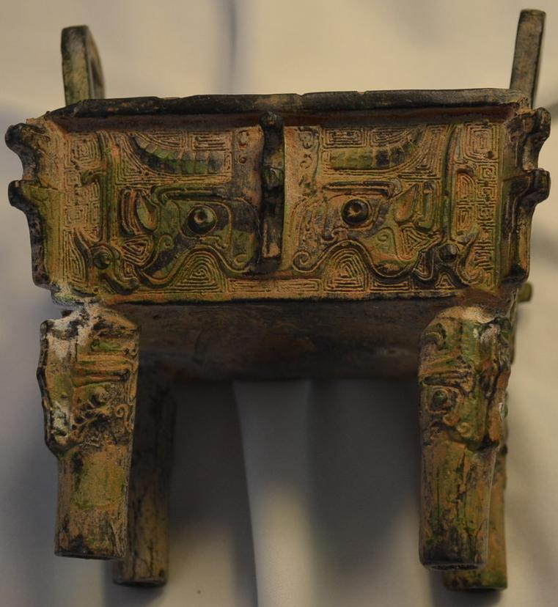

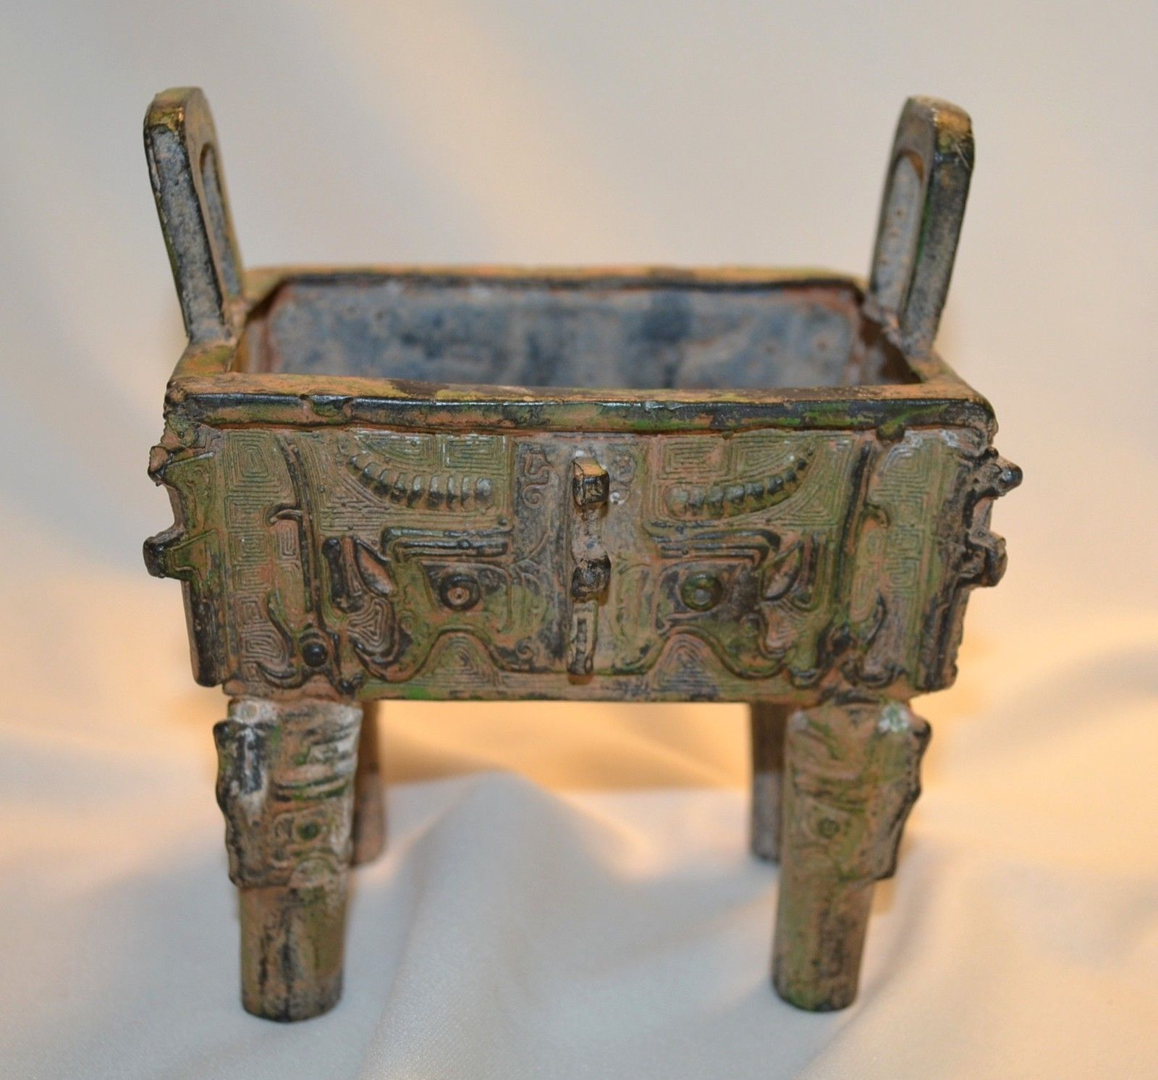

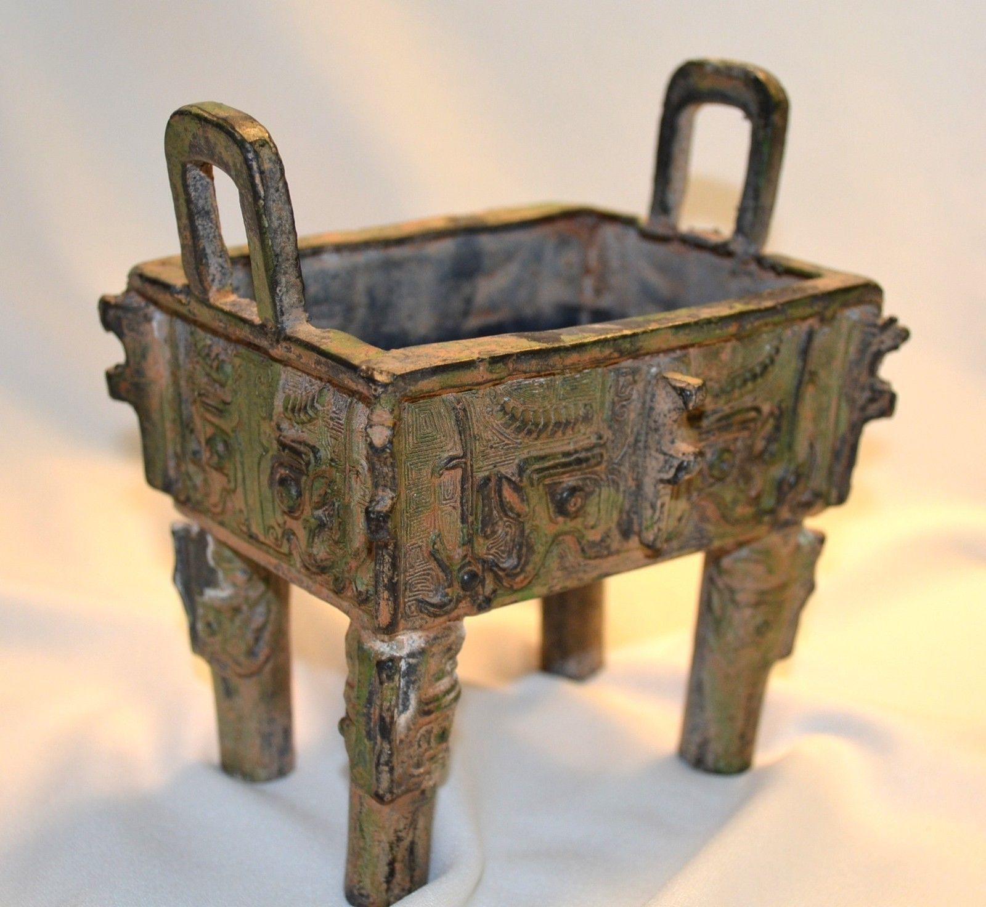 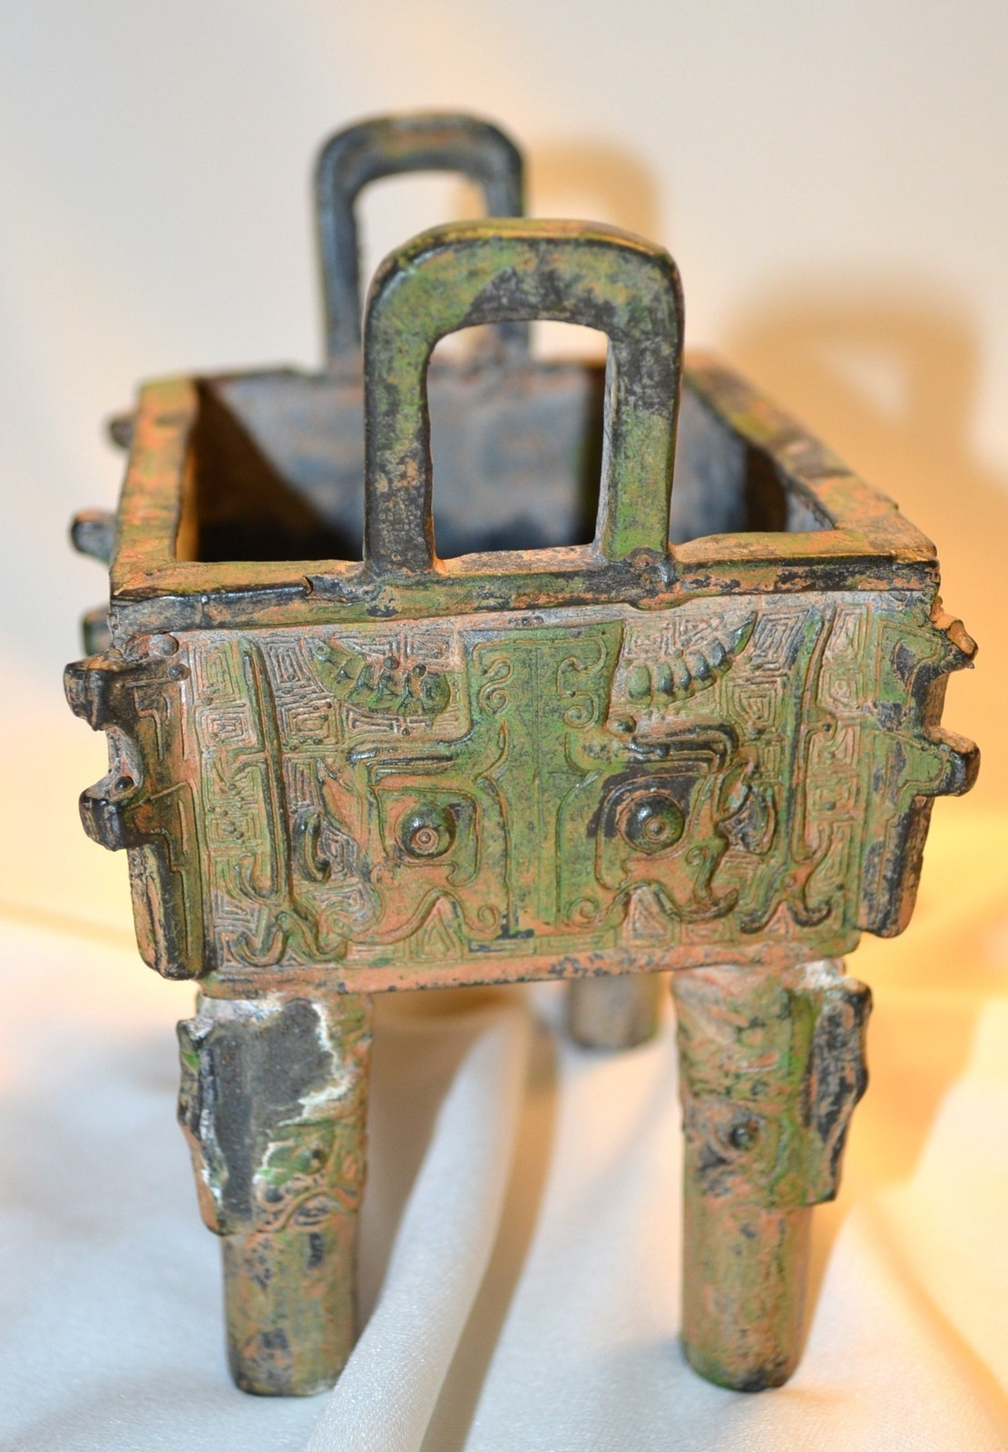 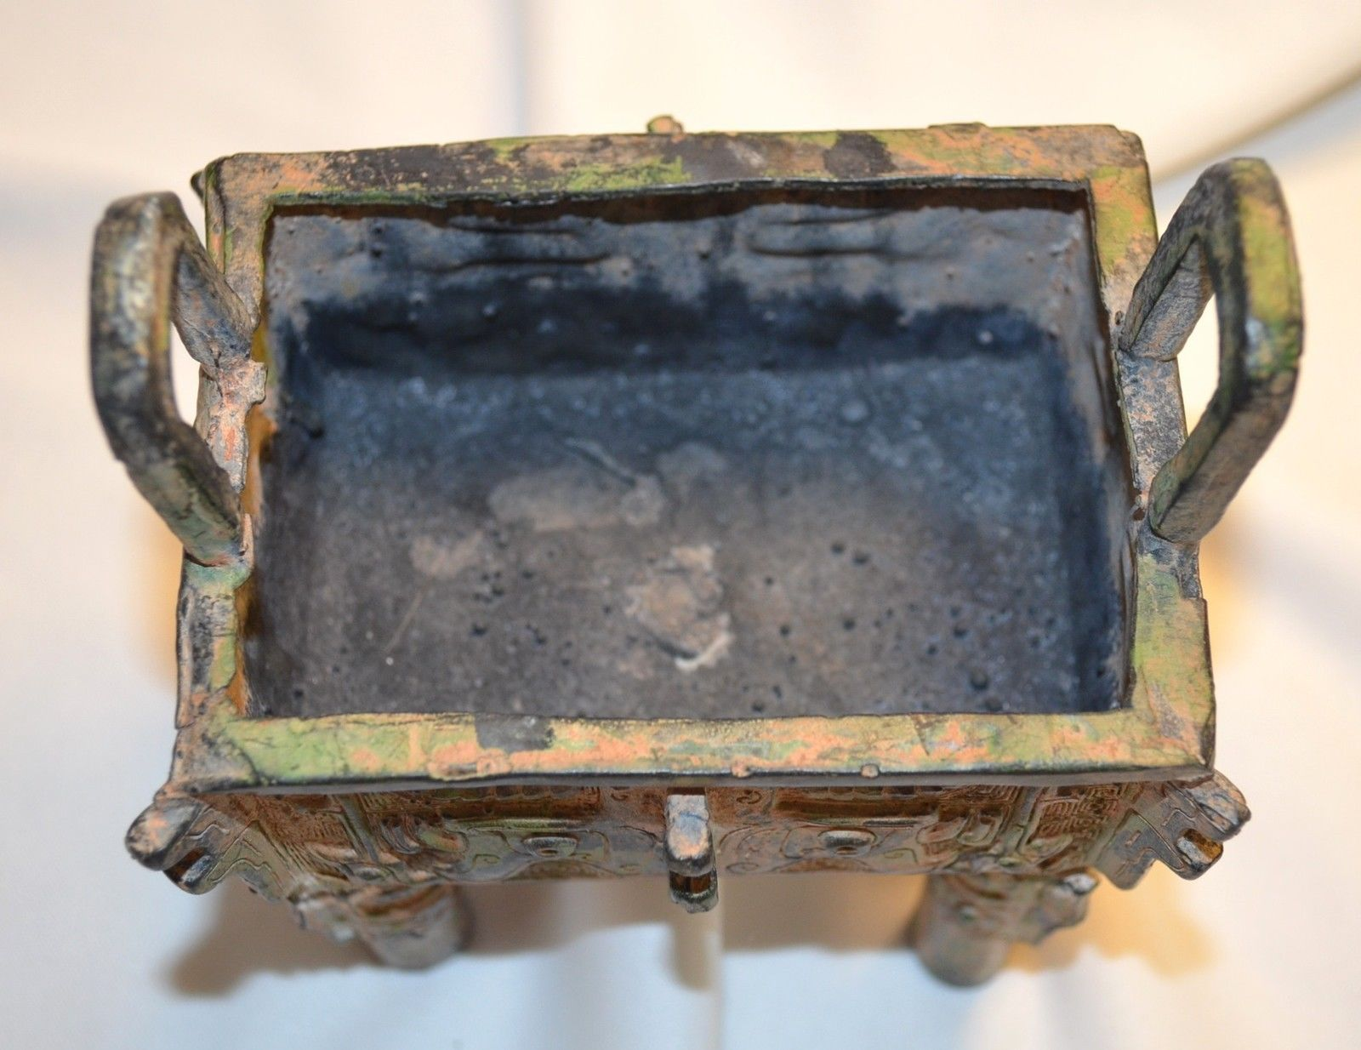 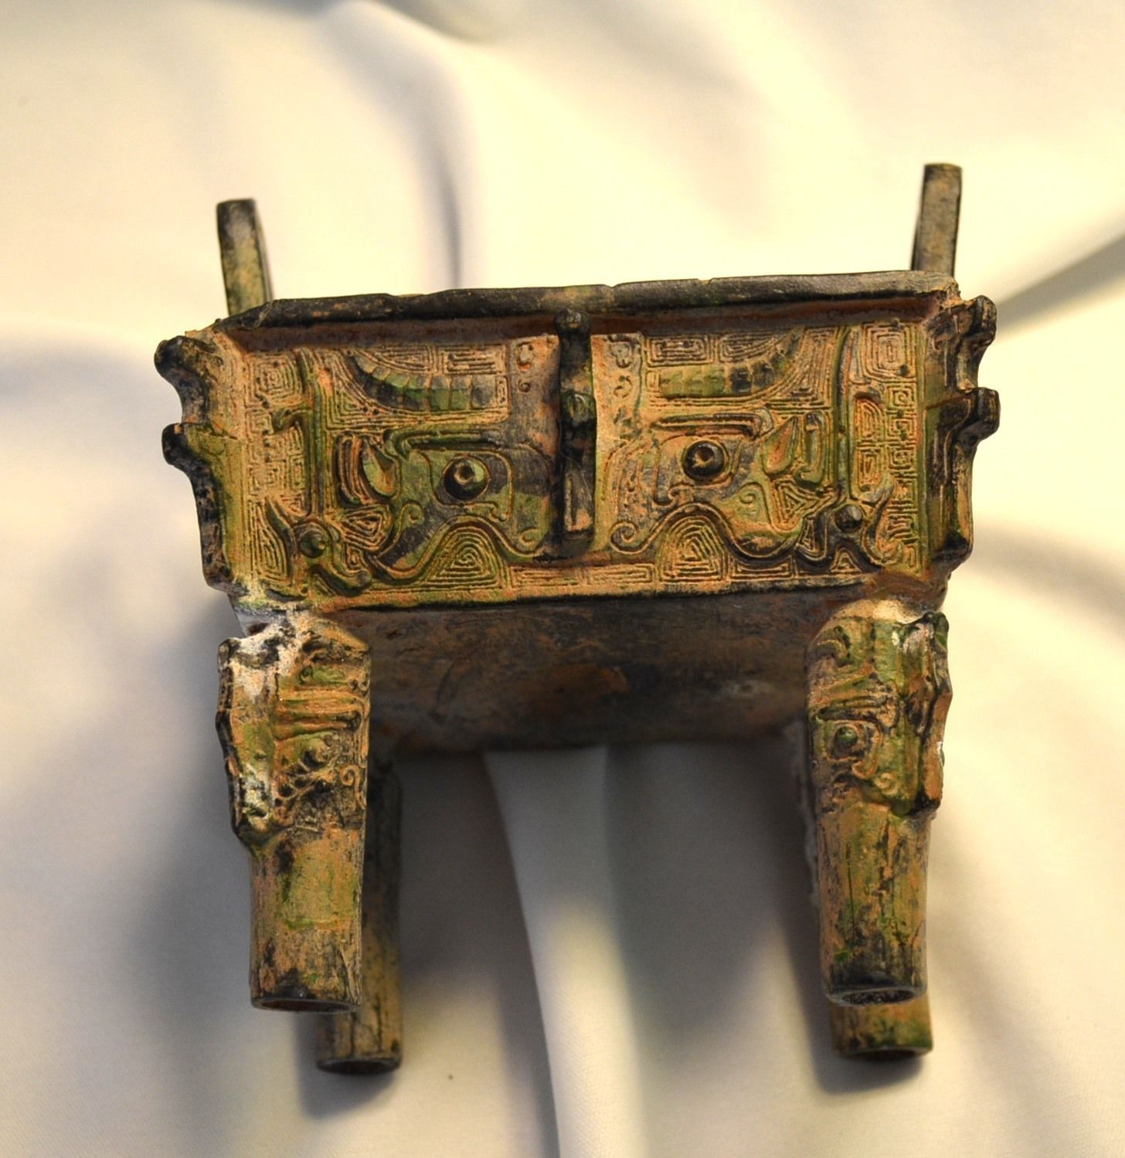

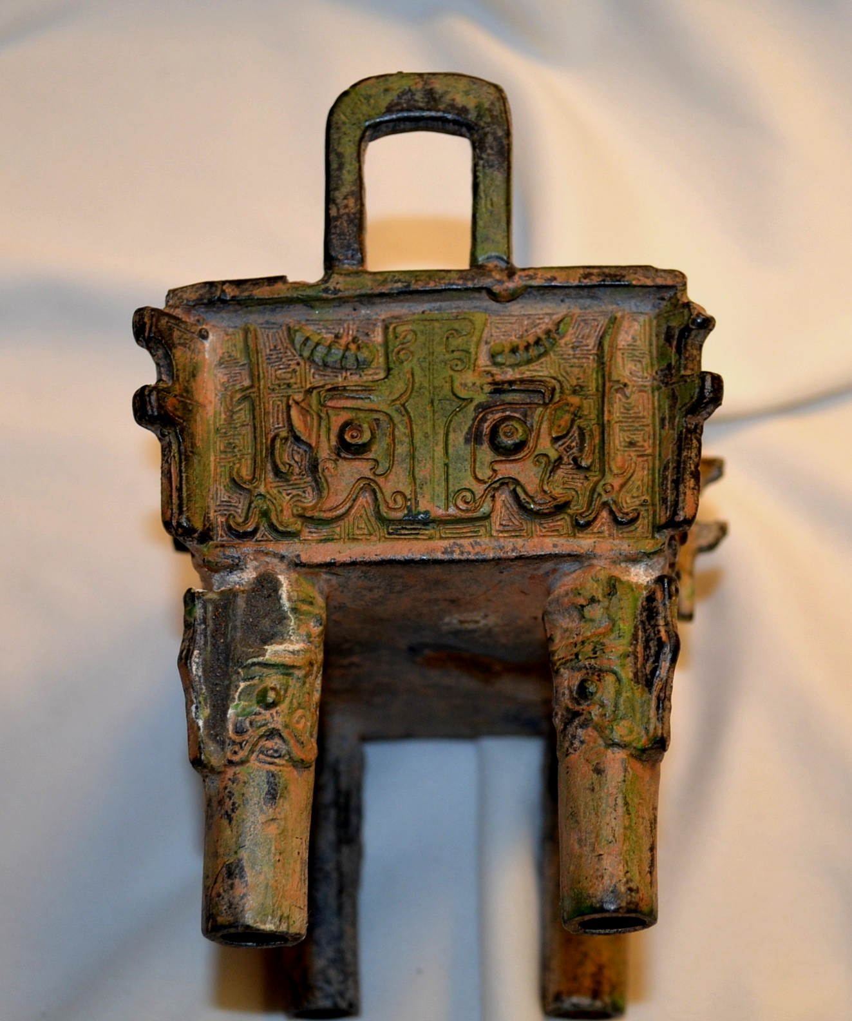

Case No.: 5

Accession No.

Formal Label:

**Display Description:**

Accession Number:

**LC Classification:**

Date or Time Horizon:

Geographical Area:

**Map:**

**GPS coordinates:**

Cultural Affiliation:

Media:

Dimensions: the body is 4 inches long; 3 1/4 inches wide; 4 inches high (handles add 7/8 inch to height), legs are 2 1/3 inches, handles are 7/8 inches high by 1 1/8 inches wide,

Weight: weight 21 oz.

Condition: original

Provenance:

**Discussion:**

**References:**